**Digital Image Processing Quiz 2**

**Deadline: 12am March 3**

**Student Number : 2017002106**

**Name : Mahadi Sajjad**

1. What is sampling and quantification?

An image needs to be discretized to become a digital image before it can be processed by a computer. The discretization of spatial coordinates of images is called spatial sampling, and the discretization of grayscale is called grayscale quantization. Sampling is divided into uniform sampling and quantification and nonuniform sampling and quantification. Digitizing the co-ordinate value is called sampling. Digitizing the amplitude value is called quantization.

2. What is image transformation?

Image transformation is a specific set of image processing operations where a function or operator takes an image as its input and produces an image as its output. An image transform can be applied to an image to convert it from one domain to another. Viewing an image in domains such as frequency or Hough space enables the identification of features that may not be as easily detected in the spatial domain.

3. Programming: submit the codes and results.

Please use commend cv2.line, cv2.rectangle, and cv2.circle to draw a line, a rectangle and a circle in an image(you can select an image). Of course, you can just practice the codes in lecture 4.

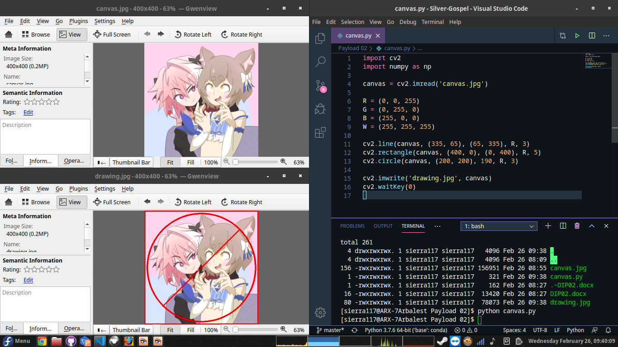

4. Programming: submit the codes and results.

Select an image, then shift it up and left. Of course, you can just practice the codes in lecture 4.

